The Twelve Symbols on the White Handled Knife

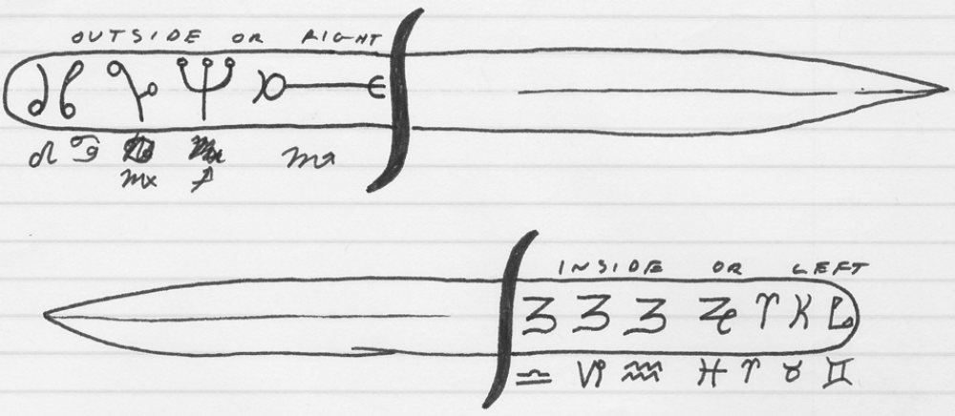

The white knife should be made or bought and dedicated in a day of Jupiter or Mercury when Mars is
in Aries or Scorpio and during the waxing or full moon. Paint runes on the same day else on a
day of the Venus when the Moon is in Capricorn or Virgo.

